June 17th, 2012
Hi
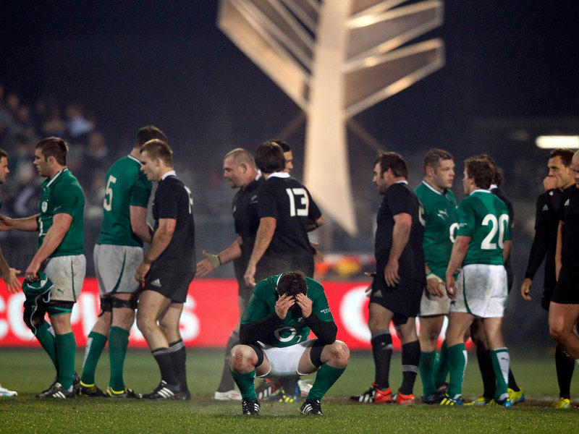
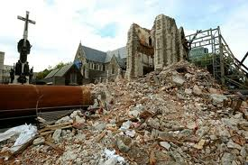
I am writing above a letter from five years ago, simply because it has the same date as today, the 17th. May be interesting to read about some events way back. I noticed in it a reference to an ABs game. I had forgotten about Rugby for a while, so looked it up just now and found that there was a test yesterday between NZ and Ireland in Christchurch. Ireland nearly won but a drop goal by Dan Carter in the last minute gave NZ a 22-19 win. As the game was in Christchurch, I guess they have patched up the ground following the earthquake. And talking about the Chch earthquake, they are going to replace the cathedral in the square out of cardboard!! Should be earthquake proof! It is being designed by a Japanese architect (who is doing it free of charge) who has designed other buildings out of cardboard (including a cathedral in Kobe, Japan following the 1995 earthquake there). It is supposed to be temporary but sometimes temporary constructions can become permanent particularly if people start to like them. The classic example is the Eiffel Tower which was supposed to have been dismantled following the world exposition is Paris.
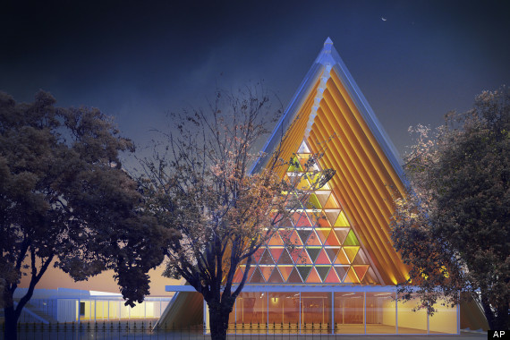


As I mentioned last week, most of that day was spent finishing the revision of the Singapore lower secondary science books. That is not the end of the work though; there is still at least one more round. After evening dinner that day, I sat on the balcony for some time while I had a yoghurt. This is the first time I have sat there. There has been some hot weather this past week. On one day, the maximum around these parts was 34⁰C and even the minimum was above 29⁰C!! Other days were a bit cooler. Cleaned the flat yesterday, the first time for three weeks! I was going to do it last weekend but the work on the books precluded that. Only took about an hour and not really that much dirt. There was some dust on the piano, so I removed that, the first time it was necessary to do so since being here. I went to the hotel the other day to check for any mail and found that the leasing desk had gone; I guess that means there is very little leasing going on (I am not surprised given the very high rates now). Do you remember this desk - it as a long desk just opposite the lifts in the lobby?
Because of the hight temperatures, the water temperature in the pool reached 30⁰C. But still all right; I imagine the water in the hotel pool is about 33⁰C by now. Did 10 km for the five-day week, but only 1.3 km on Wednesday as the pool closed because of a thunderstorm.
The other day, the CE-elect observed a one-minute silence at some public gathering for the 'suicide' of a dissident in China (probably against his will as he said he would not comment on the incident). Have you hear about this incident? The guy was a 1989 protester and dissident who had been released from prison only about a year ago. Well, he was found hanged in a hospital recently. The authorities said it was suicide! But nobody in HK believes that! To start with, he was blind. To imagine a blind person getting out of bed and being able to find some way to hang himself, and given that he was probably being watched 24/7, just stretches all credulity. There have been quite a lot of protests in HK over it, and even people in the current, outgoing administration have spoken out about it. Also, several local representatives to some of China's senior councils have called for an investigation. However, the central government may not be able to do much. The problem is with officials in provincial and municipal governments, who often do what they like with impunity. I was reading in last week;s Time, that central government officials often do not know what is happening ion the provinces and have to find out by going online and listening to gossip, just like everybody else!!
With a little help, I have probably worked out what was going on at Tom's graduation. I mentioned last week that there were no photos from his graduation two years ago. That seems to be because it must have been for his Ph.D. but had to wait until completing his MD before officially graduating, which seems to be the HMS practice. Also, from the pictures of Leonie in an academic gown, I thought she was just wearing her MD gown for the sake of the occasion. I had no idea that she too was graduating, with a Master's in Public Health.
That's about it
Cheers
June 17th, 2007
Hi
Not that much to write about.
Have had some heavy rain at times. But then, rainfall in June is, on average, the highest of all months. In spite of this, managed to get five swims. One swim was during a thunderstorm, which started just as I entered the pool, though they did not actually close the pool until I had finished
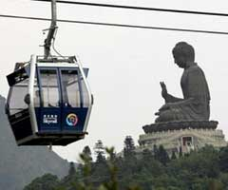
Uncle Bruce left having been in HK almost a week. Nadine arrived late on Friday night. She leaves on Tuesday.
One cabin from the Lantau cable car system plunged 50 metres to the ground during an after-hours high-speed test run. No one was in the cabin. This was just after the system had been opened following a three-day closure for maintenance. The cable car system has been closed indefinitely until it is determined what happened.
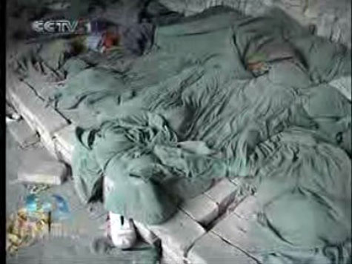

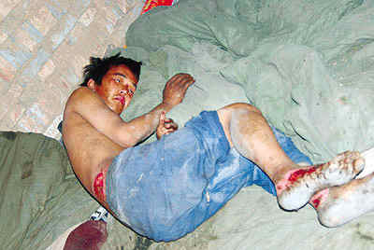
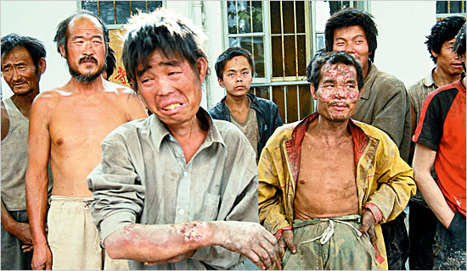
More unfavourable news from China this past week. First, factories in southern China have been accused used of using child labour and low pay to make goods for next year’s Olympic Games. Then there was the report of a thousand or more slaves working in brick-making factories. Men and children, some as young as eight, were tricked, kidnapped or sold to work making bricks. They were starved, beaten and forced to up to 19 hours a day in appalling conditions. Many were killed, some even buried alive! Raids involving tens of thousands of police have rescued about 500 of the slaves. The picture on the top left shows a ‘dormitory’ for some of the slaves.

Went to the hospital for a regular check-up. I had to wait a long time; I was almost the last person waiting. Next appointment in 6 months.
There seem to be so many anniversaries of wars! The latest is for the Falklands war, which was 25 years ago.
On TV, I saw a very brief but interesting item on a Royal Navy helicopter display team. They were performing at a place called Yeovilton, in England. Do you remember that place? We visited it in 1990, had a look through the air museum, and walked through the Concorde, which is on display in the museum. The three of you then played in a playground outside. The air display was spectacular.
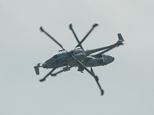
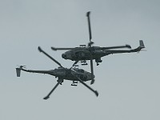
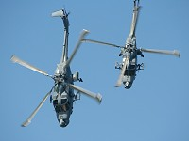

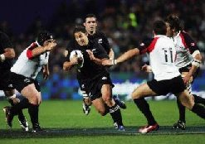
On TV yesterday, watched the All Blacks unconvincingly beat Canada and then in the evening, in first tri-nations match, SA just beat Australia. NZ play SA in Durban next Saturday.
That about it for now.
Cheers

